Robotics – Assignment Report
- Square Tracing Robot
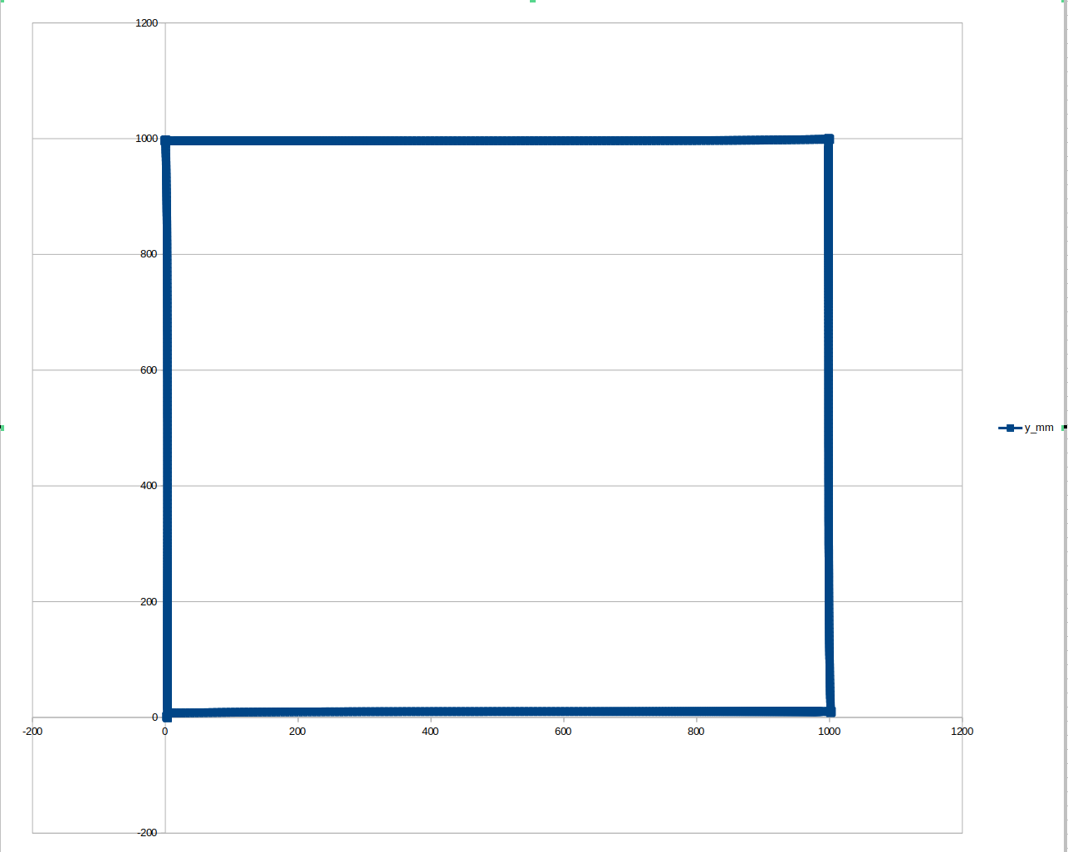

Position Controller Explanation
- The robot is coded to go 1 meter for each side by forming corners in millimeters, also my code uses a position-based control system to calculate distance and adjust velocity as it reaches the target. The robot's linear speed is controlled proportionally to the distance from the target, allowing precise positioning. There are techniques used in my code to handle small deviations include position tolerance, PID control, stabilization phases, and continuous heading correction, which also include odometry feedback to detect corner positions and uses /odom topic for position updates and odom_callback for current position.
- PID controllers are ideal for square tracing robot applications as they automatically adapt to physical changes. They continuously reduce the error margin between current and final states until the robot reaches maximum position tolerance. PID controllers work without requiring a mathematical model making them adjustable to any robot. My code uses proportional terms with larger integral terms, indicating that the primary response comes from the current error. PID components provide accurate movement, with proportional terms laying out the primary driving force toward the target. They also ensure stability by capped linear and angular velocities and reset accumulated errors when changing states.

- The translational velocity gradually decreases as the robot approaches each corner. The primary velocity control mechanism is proportional to the distance remaining. There is a maximum speed limitation of 0.20 m/s regardless of how far away the target is, which prevents excessive velocity that could lead to control issues. If the robot uses constant speed instead of the implemented adaptive approach, it would be simpler, less computation and predictable travel times between corners, however, will have higher risk of overshooting target positions, stopping abruptly, also can reduce the positioning accuracy. My current implementation adapts speed approach and natural deceleration will take place as the robot will reach the targeted corner and significantly will improve the accuracy of the robot's position. Even though there are these advantages, it can be complex to code.

Code Structure & Implementation
- My code manages to execute a formation of square which is accomplished by corner definition array angle array, state machine implementation – the robot cycles through six distinct states managed in the control_loop() function. The indexing system is where the corner_idx variable tracks which corner the robot is heading toward, cycling through the four corners of the square. This is how the sequence goes:
- Move forward -> Stop
- Stop -> Turn
- Turn -> Stop
- Stop -> Move forward
- Repeat
Each transition explicit zero commands to ensure complete stops, stop variable updates, timer resets for stabilization phases and PID error accumulation resets for clean control transitions.

- The data my code selects and collects by subscription to odometry topic, data extraction in callback and quaternion to Euler conversion; with all these techniques conversion from meters to millimeters also takes place. The angle conversion in my code makes it easier to calculate the movement and heading in that direction. This helps the robot to know how far it has moved and where it should go next. The data logging frequency is determined by the ROS topic publication rate of the /odom topic. The data is then stored in a csv file format with the two columns of x & y, also before logging the data, which is converted as my code suggests during logging.

- My code also uses ROS 2 node architecture to achieve parallelization where the entire functionality is encapsulated in a ROS 2 node. This all is executed via callback system where it is done by control loop timer and odometry callback. Synchronization strategies are used where my code uses system time for control loop timing rather than ROS timestamps. Furthermore, the robot maintains state variables (current_x, current_y, current_yaw) that serve as an implicit synchronization mechanism between logging and controlling.

Trajectory Data Analysis
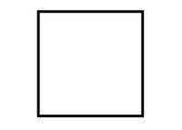
- The trajectory diagram depicts the robot's x and y coordinates during its movement, outlining a distinct square route with each side measuring 1000mm. A comparison between the actual path, represented in blue, and the ideal square path—which would feature perfectly straight lines and precise 90-degree angles—reveals only slight deviations during the straight segments, with nearly exact alignment at the specified corner points.

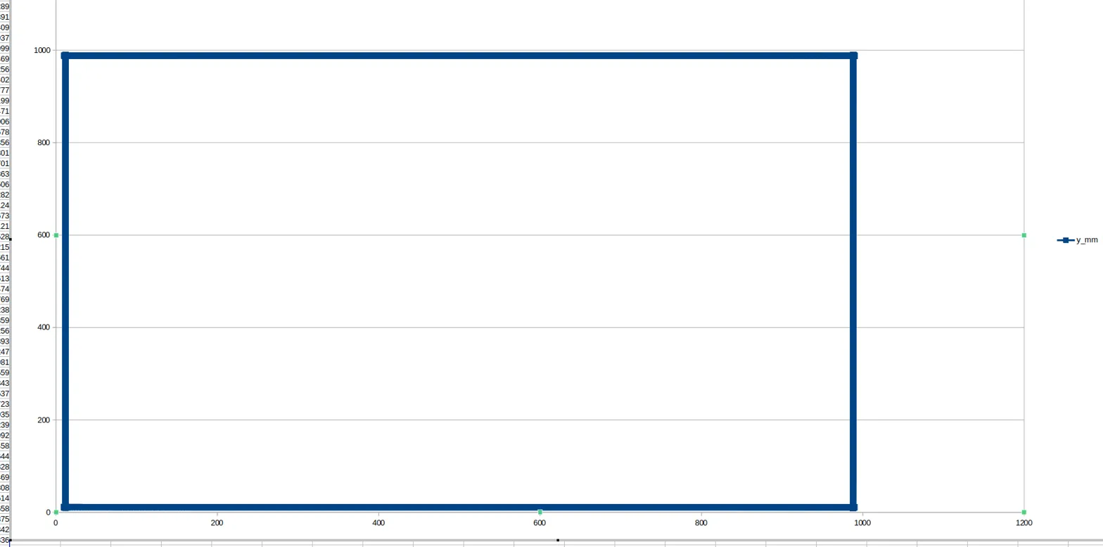 | 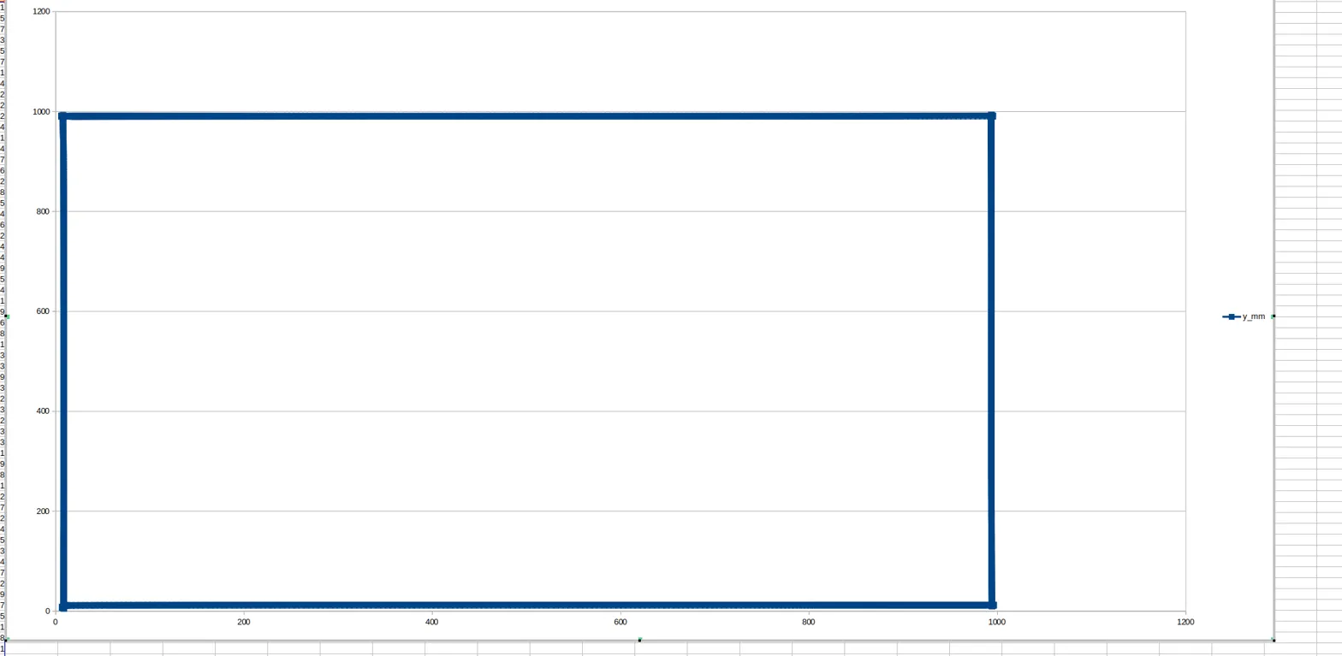
0.10 | 0.15
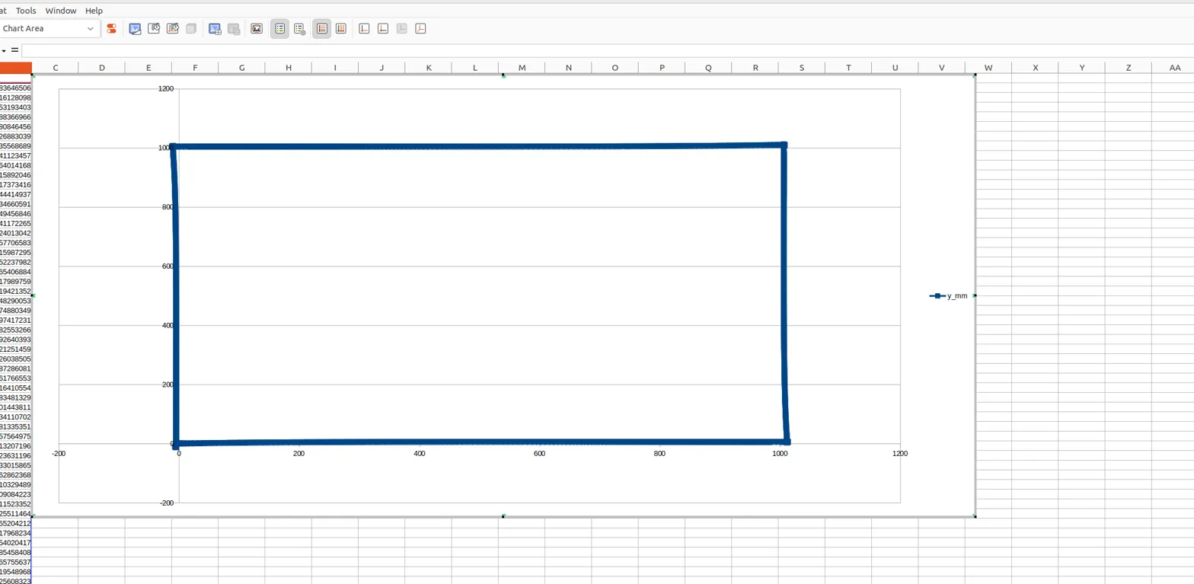 |  | 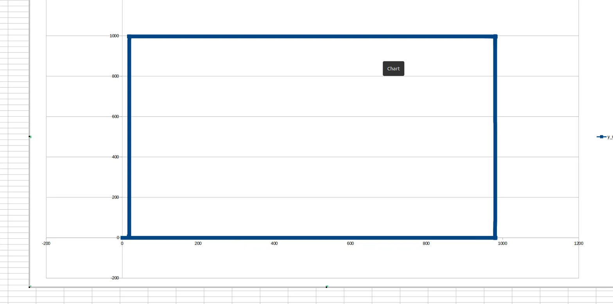
0.25 |  | 0.05
 |  | 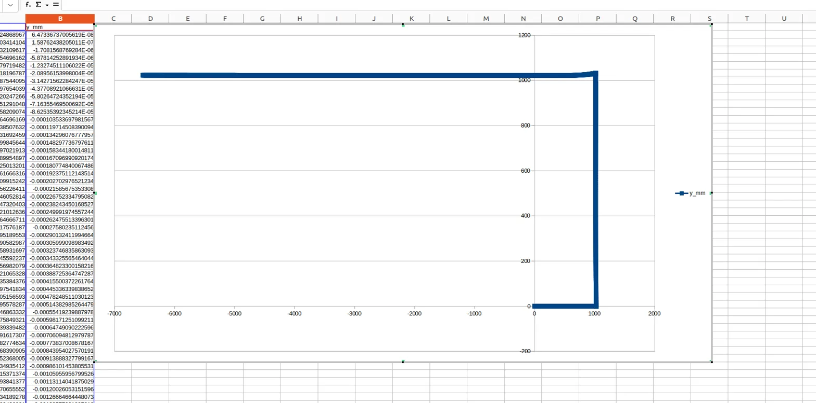
0.075 |  | 0.3

- The findings from my square trajectory tests conducted at various linear speeds, while maintaining a constant angular speed of 0.25 rad/s (after I experimented with different angular speeds like 0.50 and 0.75 rad/s), indicate distinct performance trends. At lower speeds (0.05 - 0.10 m/s), the robot demonstrates enhanced precision, exhibiting minimal corner overshot and excellent path adherence. Specifically, my test at 0.05 m/s revealed an additional line originating from the starting point prior to forming the square, while the 0.075 m/s test did not conclude precisely at the initial coordinates (0, 0). In the medium speed range (0.10 - 0.15 m/s), the robot successfully created a well-defined square, achieving a commendable balance between accuracy and efficiency, accurately reaching critical points such as (0, 0), (0, 1000), (1000, 1000), and (1000, 0). At higher speeds (0.20 - 0.30 m/s), performance exhibited considerable variability; 0.20 m/s was found to be optimal, as it accurately initiated and concluded at (0, 0). In contrast, the 0.25 m/s test resulted in rounded lines rather than sharp corners, and the 0.30 m/s test failed to complete the square due to system breakdown at that speed. Furthermore, increased speeds led to more significant corner overshooting, oscillations during straight segments, and notable trajectory deviations during turns, attributed to momentum effects. In summary, the optimal performance for my system seems to lie within the range of 0.15 - 0.20 m/s, effectively balancing precision and efficiency.

- The tracking errors identified in the trajectory data primarily appear as minor deviations from ideal straight-line paths and slight inaccuracies at corner points, become increasingly noticeable at higher speeds. These variations are likely attributed to several factors, including errors in odometry calculations and the inherent limitations of the PID controller parameters (linear_kp = 0.0005, linear_ki = 0.00001, angular_kp = 1.5, angular_ki = 0.01). The PID control in my code keeps the velocity updated at all times to maintain the stability and accuracy.

- Mapping Robot

Navigation method
- My code implements random walking strategy with obstacle avoidance. This approach combines with continuous forward motion as the default behavior and the obstacle is only detected if it is closer than 0.2 meters. My method is useful with unknown environments as it requires no prior knowledge of the space which needs mapping and can cover all accessible areas if time is given. It may be a time-consuming process as it may visit areas already visited multiple times while others can remain not mapped for extended periods. Each of the movement decisions depends only on the current state (a state where checking if the obstacle is detected or not), additionally, the memory from the previous state does not influence the current decisions made. The uniform random sampling (random.random() < 0.05) in my code creates a probability that either it will detect or avoid an obstacle. This results in getting an expected mean free path and this random direction change creates an unbiased random walk in orientation space. Obstacle avoidance takes priority over random walk behavior. However, when obstacles are encountered repeatedly, no learning or adaptation occurs. The advantage of mapping is the guaranteed probability of completeness which means the robot will eventually visit all accessible states.
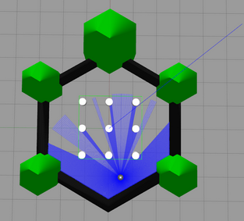

- My entire laser scan Is reduced to a single scalar value (minimum distance) which means sensor data reduction. Assuming a typical LiDAR with 360 degrees coverage & 1 degree resolution, about 99.7% of spatial information is removed which means no directional information about the obstacle location is retained and there is no similarity can be seen between the obstacle configurations that reduces the same minimum range. Now with binary decision boundary, the hard threshold at 0.20 meters creates a step function activation with no proportional response with no consideration of robot dimensions or kinematic constraints. The basic implementation releases single velocity commands without duration control or execution confirmation and as mentioned before, no adaptation of the environment complexity is required. File I/O operations occur in my callback thread which can potentially cause timing issues. Moreover, no data decimation or filtering is used in my code to reduce redundant points is used nor does the state estimation to improve pose accuracy take place. The linear log format prevents efficient spatial queries with no indexing for quick retrieval of previously visited locations. Furthermore, the collected data exists in isolation from decision making process. Most importantly when the mapping of the environment is completed, no termination criteria is set to stop the robot from continuing. The data presented in my csv file is not restrained or summarized, making it grow over time with no optimization of exploration.

- Odom_callback is the function in my code where the odometry data of the current position of the robot is tracked and logs its updated position into the csv file. This allows the robot to record its path and track where it has been.

Obstacle avoidance
- My laser scan data processing employs a minimalistic approach, subscribing to the /scan topic via ROS and implementing a straightforward detection method. In my laser_callback function, the system extracts only the minimum distance value from the entire array of range readings and applies a simple threshold comparison at 0.20 meters to make binary obstacle detection decisions.

- To process 360° range data, the approach adopted in my code is computationally efficient yet reduces the amount of information by summarizing numerous directional readings into a single scalar value, defined as min_range = min(msg.ranges). While this threshold-based detection allows for rapid decision-making, it falls short in differentiating between various obstacle situations that may require more advanced responses.

- My obstacle avoidance algorithm employs a strictly reactive method, executing a predetermined series of movements when obstacles are detected within a 0.20 meters range. Upon activation, the robot retreats at a speed of 0.20 m/s for a duration of 2.5 seconds, comes to a full stop, then turns right at a rate of 0.50 rad/s for 7.5 seconds (approximately 215 degrees), after which it ceases turning and continues its random walking pattern.

Results, analysis and visualization
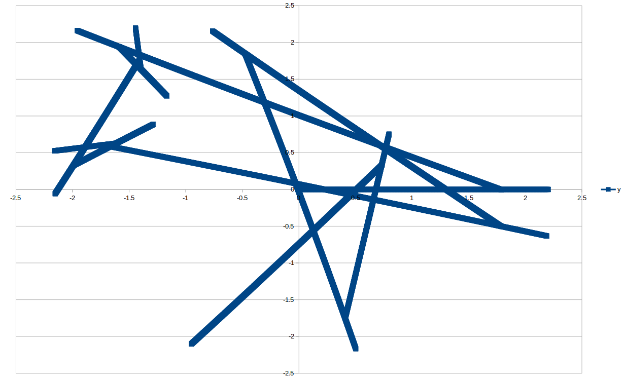
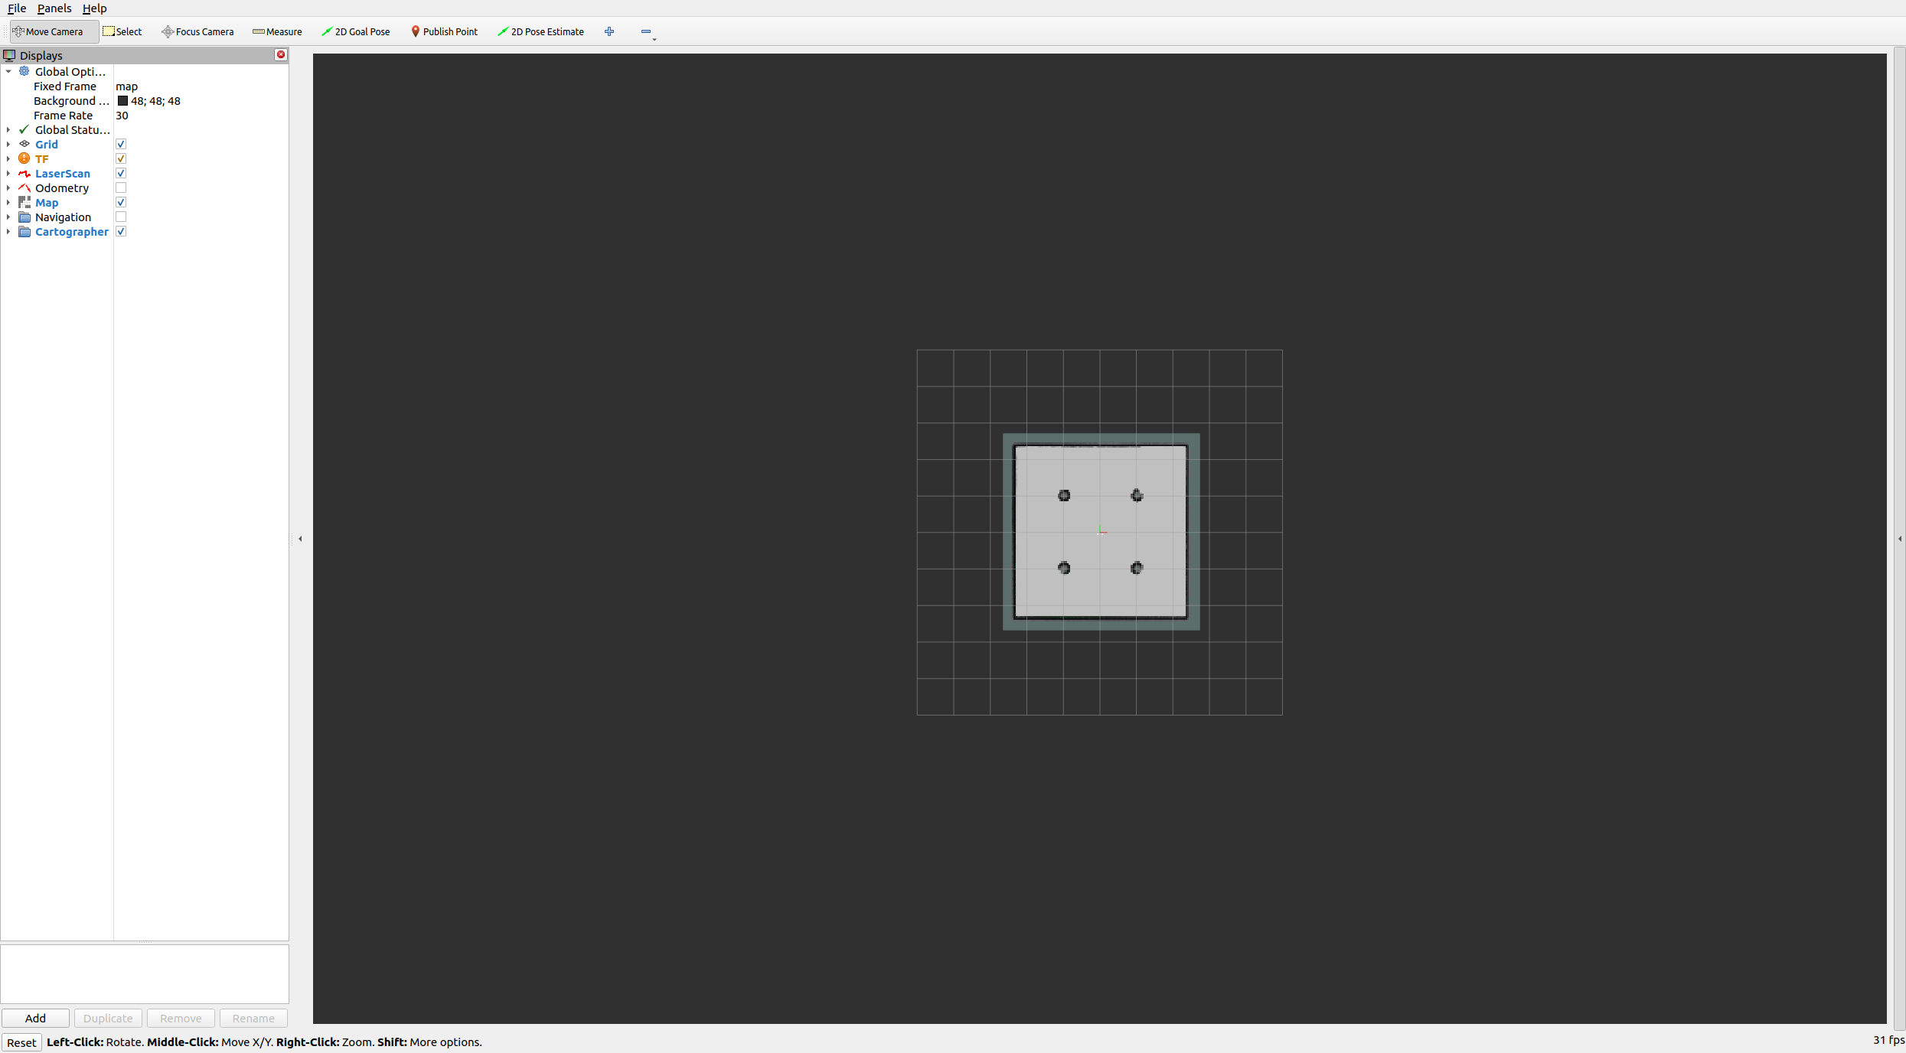
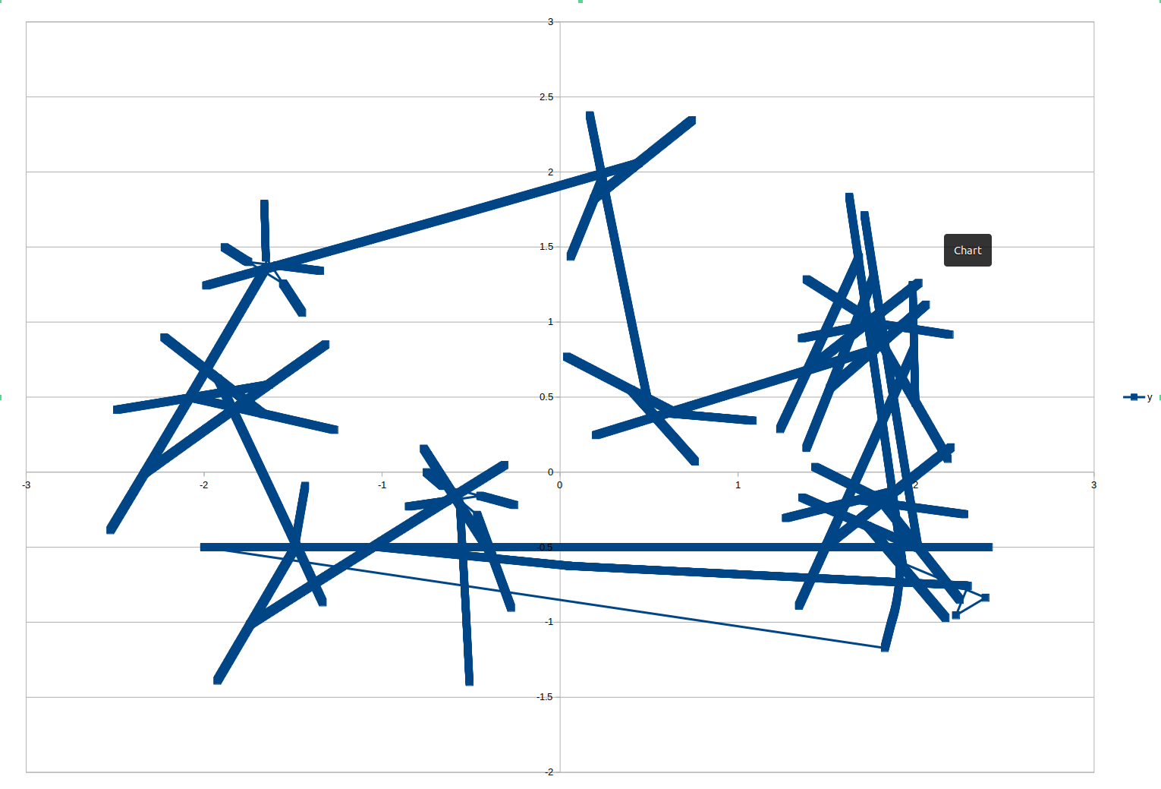
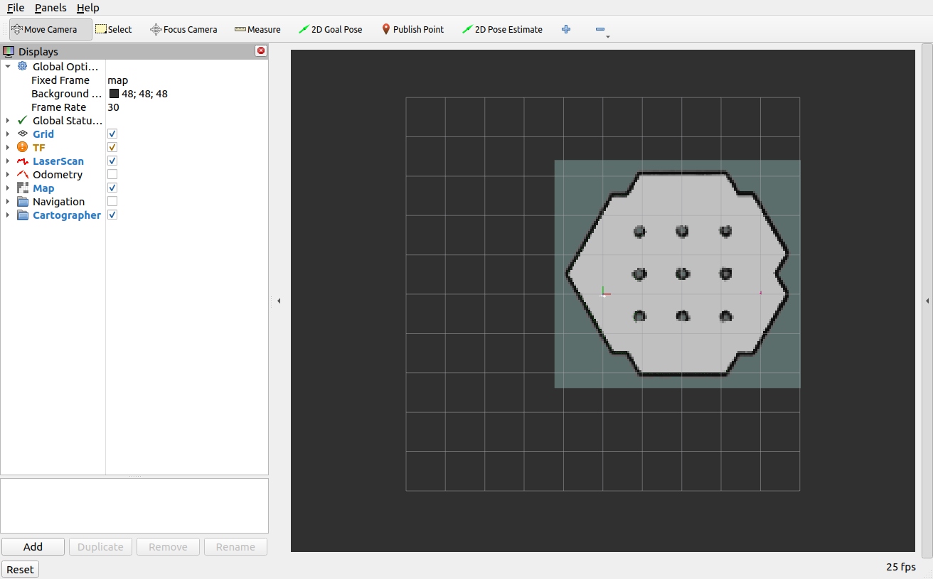

- The generated maps shown on Rviz are two environments – gazebo and stage 2, providing a structured representation. These images indicate defined walls and obstacles; moreover, my mapping algorithm captures successfully the key structure of the space with internal features and boundaries. In comparison to the anticipated layout, the overall accuracy seems to be quite high; however, slight distortions may exist because of localization errors.

- For a clearer comprehension of the robot's movement, it is crucial to incorporate trajectory overlays onto the generated map. These paths demonstrate the robot's navigation through the environment during the SLAM (Simultaneous Localization and Mapping) process. Regions with a high density of movement paths may signify areas of interest or spots where the mapping process necessitated modifications.

- The methodology I employed for mapping seems to be successful in identifying the key characteristics of the environment. The distinct boundaries indicate that the LiDAR-based SLAM technique has demonstrated a high level of consistency. I could use enhancing real-time filtering methods and refining loop closure detection in future which could significantly improve the overall accuracy of the map.

- RViz was instrumental in visualizing sensor data, the robot's estimated location, and the generated map. The interface presented key components, including the LiDAR scan (LaserScan topic), transformation frames (TF), and the completed occupancy grid. The screenshots I provided illustrate the robot's perception of its environment.

